Audio Tape Digitization Guide
LGBTQ Oral History Digital Collaboratory

May 23, 2017
V.1.4 (PC)

Dr. Elspeth Brown, principal investigator
Document prepared by: Cait McKinney and Al Stanton-Hagan

This guide is designed for volunteers digitizing audio tapes for the LGBTQ Oral History Digital Collaboratory at the CLGA. It provides instructions on creating digital versions of audio tapes and creating information about the contents (aka meta-data). It is based on modified best-practices procedures from Indigitization: Toolkit for the Digitization of First Nations Knowledge, and the tape-digitization system at the Lesbian Herstory Archives.

Table of Contents:

- Recording information from the physical cassette tape……………………………..3
- Creating a digital copy of the tape………………………………………………….…4
- Saving, naming, and managing files…………………………………………………..6
- Appendix A: Setting up the digitization station……………………………………..10
- Appendix B: Troubleshooting………………………………………………………...12

Step 1: Before you begin – locating your tape and recording information from the physical cassette tape

When you arrive at the CLGA, you will be given a tape or one will be waiting for you in the box in the A/V room labeled “Collaboratory Digitization.” Before you insert the tape, record the title and any other information written on it using the procedure below.

Recording metadata using the Google form:

Open our project Google form at http://tinyurl.com/klscyfd.

Form:

During your digitization session, you will fill out a spreadsheet with data documenting the files you have created. The form contains the following fields:
Title of Tape; Accession #; File Name; Noise Reduced File Name; Date Recorded; Date Digitized; Digitizer; Collection; Original Format; Tape Condition; Tape Cover Description; Original Length; Edited Length; Multiple Recordings on Tape?; Notes; Physical Location.

Complete the form for each side of a given tape. “Title of tape” and “Accession #” can be found on the tape. “File Name” should be created according to our naming convention, which is “[Accession #][Tape Title] [Tape Side A or B]” Example: 2012-001-02T Mikey’s Oral History A.wav, or 1998-015-45T Jane’s Story B.wav. For the noise-reduced copy, add [NR] to the end, Example: 1998-015-45T Jane’s Story B NR.wav. “Multiple Recordings” is a field to document tapes that have multiple recordings on them-you should give each recording a description and indicate the time it begins in the file. “Tape Cover Description” is whatever is written on the tape. “Notes” is the field where you put the descriptive information you have recorded about the content on the tape.

Step Two: Creating a digital copy of the tape

Preparation:

- Inspect the cassette tape. Make sure there is no visible dirt or debris on the tape. Manually turn the spindles a few turns using a pencil and make sure they turn freely. If you have any concerns about the condition of the tape, set it aside and move on to the next tape.
- Put the tape in the deck with the side you want to play facing out (it does not matter if you use deck a or b).
- Determine whether the tape has been recorded using Dolby noise reduction. Press play, listen to the tape through your headphones while toggling the Dolby NR switch on the tape deck between “off” and “B.” If there is a lowering on tape noise (hiss) but the audio signal sounds like it has lost high frequency response when the DOLBY switch is ON then set the switch to OFF. It takes a bit of practice to be able to get this right. For most tapes, the switch should be set to OFF.
- Determine the appropriate volume level to record the tape at, using the microphone slider on the far left, top menu. Adjust the recording volume so that most of the speech on the tape stays within the green zone on the audio level bar (top right). Occasional peaks into orange or even red are okay, provided that the sound waves never fill the meter.

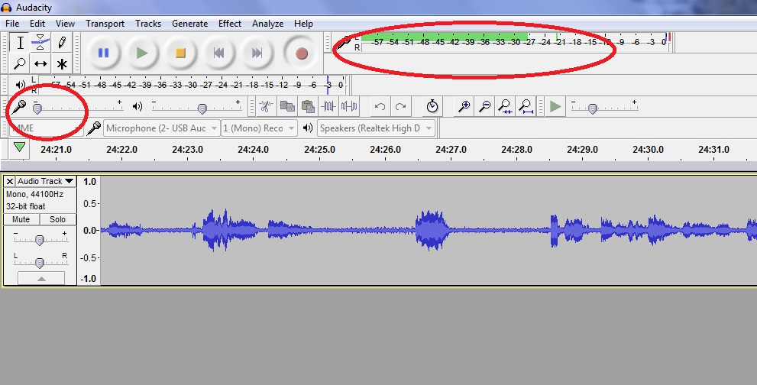
Figure 1 Recording level slider (left) and recording level audio meter (top, right)
- Rewind the tape to the beginning of Side A.

File Creation:
- Start Audacity
- Push the record button in Audacity, wait a few seconds, then press play on the tape deck. The computer is now recording the tape and you will see sound-waves in the audacity meter.

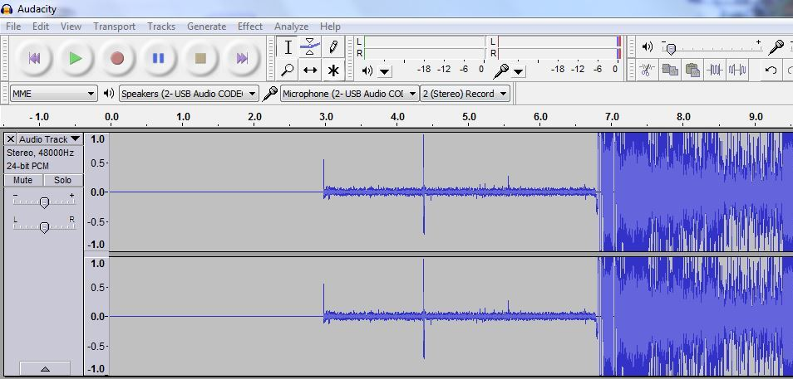

- Note down the quality of the recording. Is there a lot of static, clipping or other noise? Can all voices on the tape be understood?
- Record any changes of content that happen on the tape in the “Multiple Recordings” field of the form. For example, multiple events, speeches, or interviews could be recorded on one tape and while these will all be kept as one file, researchers will want to know what is included on a tape/in a file. Note these changes with the best identifying information you can provide, and note when the changes occur on the tape (minute 28, side A).
- Continue to record until the end of the tape. You should continue to monitor the sound in your headphones while you are doing this—in other words, don’t leave the recording unattended unless you absolutely have to. Pausing the procedures compromises the authenticity of the digital file so it is better to keep the system running unattended briefly than to stop and start the process mid stream.
- As you listen to the tape, make short descriptive notes about the content in the “Notes” field of the form. Note names of people and institutions and the general topics of conversation. Later you will write a short description of the tape to help researchers.
- Allow the tape to play through to the very end. If there is extended silence and you believe the recording is over, you can stop the tape manually. When the tape ends, wait five seconds then press stop in audacity. Record the length of file in “Original Length” in the form.
- Trim unwanted silence from the file, leaving three-five seconds of silence at the beginning and end of the recording. To delete silence, drag the cursor over the portion of the file you would like to delete, the push the delete button on your keyboard, or select edit, then delete from the drop-down menu. Record the length of the trimmed file in the form.

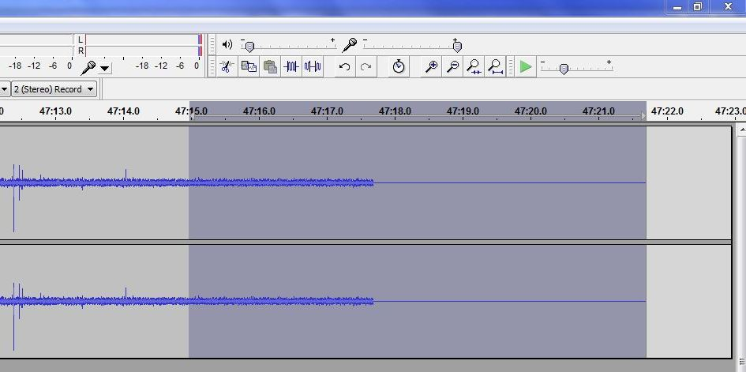

- Do not close audacity at this point—you will lose all your work and have to digitize the tape again.

Step 3: Saving, Naming, and Managing Files

Saving the files:

You will now create two files:
- preservation-quality master .wav file
- noise-reduced .mp3 file aimed at access

Note: Each side of the tape will be a separate file (Side A and Side B) and a separate entry in the Google form.

Master:
- In audacity, click file > export audio
- Select WAV (Microsoft) signed 16 bit PCM from the drop-down menu
- Choose the Audio Digitization folder on the desktop.
- Name the file according to our naming convention: “[Accession #][Tape Title] [Tape Side A or B]” Example: 2012-001-02T Mikey’s Oral History A.wav, or 1998-015-45T Jane’s Story B.wav
- Click “save”
- A metadata window will pop-up automatically. Leave all fields blank and press “ok”
- You have created your preservation-quality master and can now create a noise-reduced copy.
Noise-reduced .mp3
- Note: if there is more than one recording on a tape, you will need to perform noise reduction on each section separately. Instead of selecting the entire file during step D, select the length of one recording and remove noise using a sample from that recording. Repeat for each recording on the tape.
- You want to make the sound-waves as tall as possible to perform noise reduction. To do this, click on the bottom edge of the audio file window and drag it down to the bottom of the audacity window. It should now look like this:
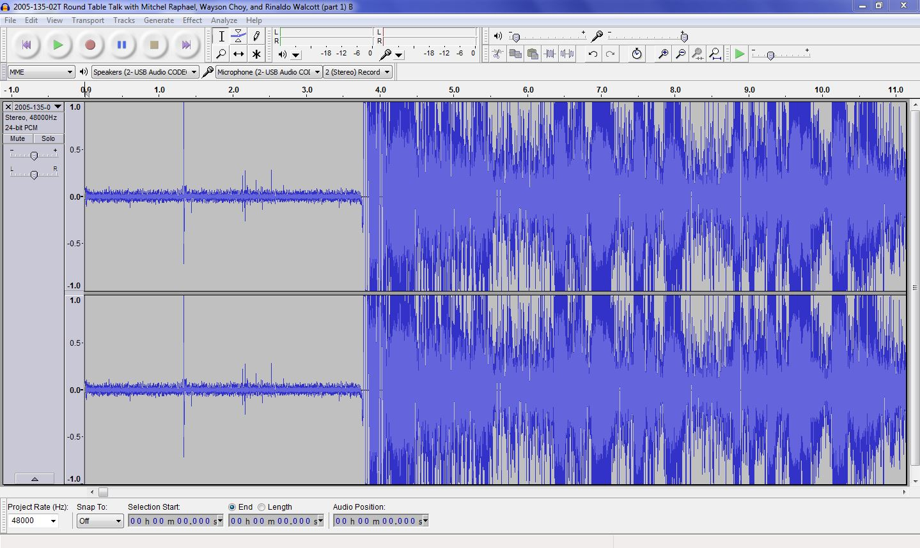
- We will be using Audacity’s automatic noise-removal settings. This works by giving the program a sample from the audio file that is just noise, usually during a pause in speech. Select a portion of this part of the tape using your cursor then click effects > noise removal. Click Get Noise Profile.
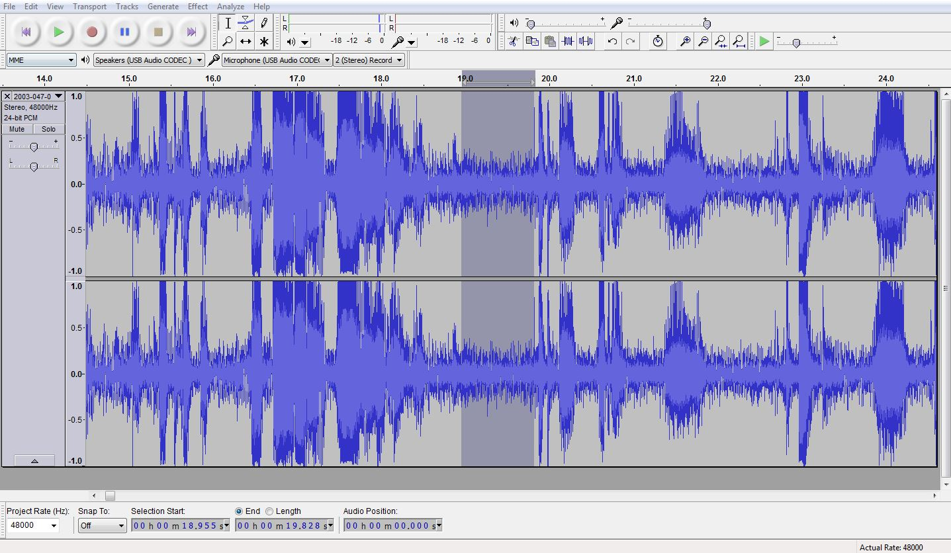
- Now select the entire audio clip: edit > select all. Click effects > noise removal. Leave all the settings at their default and Click ok. 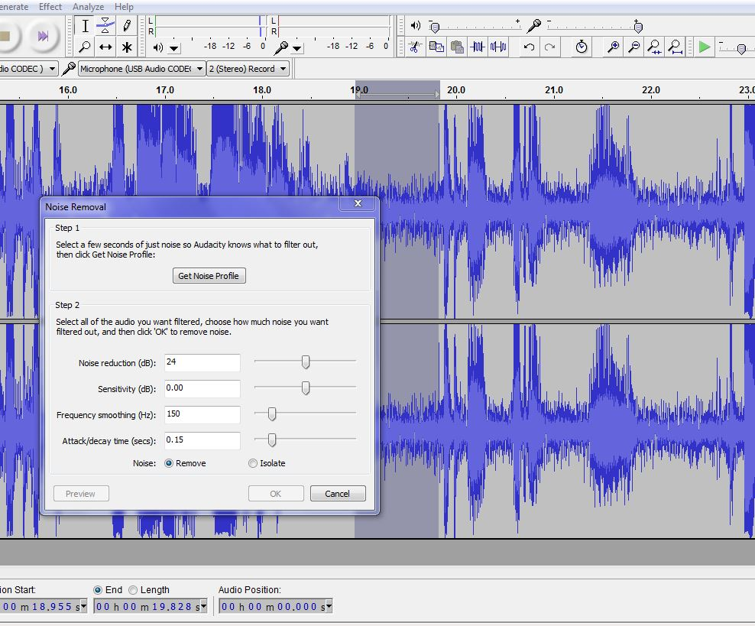
- Listen to the noise-reduced version to check the quality. You may have to perform several rounds of noise reduction for different sounds. If the quality is still poor, refer to “Noise Reduction” in Appendix B.
- Now it is time to save the noise-reduced file you just created. Click file > export audio. Select mp3 from the drop-down menu of file types.
- For the destination, select the Audio Digitization folder from the desktop. Name the file according to the same name conventions you used with the preservation master. The same metadata window will pop up automatically. Do not input anything, just press ok. You have now created your mp3 file.
- If you are creating an access copy to upload to Soundcloud, you may want to combine both sides of a tape into a single file for convenience if the total length of all files belonging to a single interview (e.g. sides A and B of a tape, or sides A and B of one tape and A of a second tape) is less than 75 minutes. To do this, open the first file of the interview. Then, open the second file and copy the whole selection by clicking Edit > Copy or Ctrl + c. Paste this into the first Audacity file at the end of it by clicking Edit > Paste or Ctrl + v. Delete excess space between them, leaving one or two seconds between the sides. Also trim all excess space from the beginning and end of the file. To name these files, remove “A” and “B” from the end of the original files. If an interview results in two or more combined files, add “Part 1” or “Part 2” etc at the end of the file. Example: “2012-001-02T Mikey’s Oral History Part 1.”

Appendix A: Setting up the digitization station

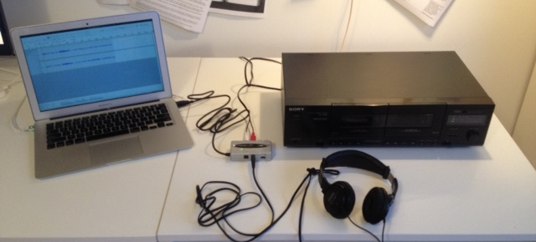

Hardware Components:
- Cassette Deck
- Behringer U-Control USB audio interface with digital output (UCA202)
- Headphones
- A computer equipped with the following software:
  - Audacity
- Two external hard-drives (one master, one backup)

How to connect the components:
- Using a white and red RCA audio cable, connect the line out on the back of the tape deck to the “input” plugs on the behringer converter.
- Plug headphones into the “phones” jack on the behringer converter.
- Ensure the “monitor” switch on the behringer converter is in the “on” position.
- Connect the USB cable from the behringer converter to the computer
- Optional: external speakers can be connected to supplement the use of headphones by connecting the output jack on the behringer converter to your external speakers using an RCA audio cable. It is preferable to monitor sound using headphones.

Setting up preferences on Audacity:
- Set the quality settings for your file. Click on “edit” and then “preferences” and then choose the menu item “quality.” Default sample rate should be 48000 Hz and default sample format should be 24-bit. Click “ok” to save settings
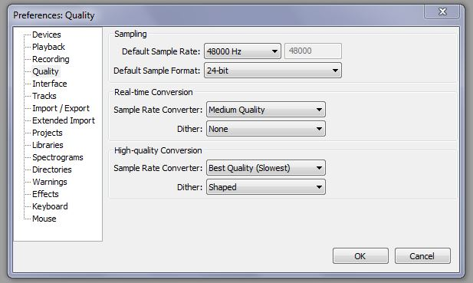

- Set the input and output to “Speakers (2 – USB Audio CODEC)” and output to “Microphone (2 – USB Audio Codec)”

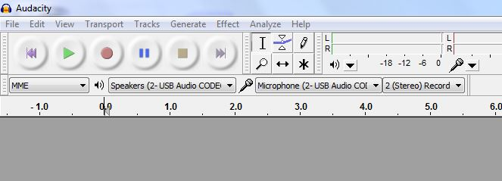

Appendix B: Troubleshooting

General:
- If you do not hear any sound at all (not even ‘tape buzz’), or do not see sound waves on Audacity when the tape plays, go through the steps in Appendix A: setup to make sure that everything is connected properly

Noise Reduction:
- If the noise reduction seems to make the sound quality worse, you can undo it using the undo button in the top right hand corner or “Ctrl+Z.” Try again using another noise sample from the tape.
- If another sample gives the same results, you can adjust the default noise reduction settings in the Noise Reduction dialog box, adjusting the top three sliders to improve the quality of the noise reduction. To do this, after you’ve collected a noise profile, highlight another part of the tape that features a normal section of talking, then re-open the noise reduction window. You can now adjust the sliders and click preview to hear what the effect of these settings on the sample you have chosen. On noisy tapes, the sensitivity and frequency smoothing sliders will have the greatest chance of improving noise reduction.
- Remember, noise reduction is not magic and there may not be much that can be done for very noisey tapes. Still digitize recordings that are inaudible, but write in the “Notes” field that the sound quality is very bad.
Saving a file:
- If a dialog box pops up that says “The file name is not valid,” make sure your title does not use any of the following characters \ / : * ? " < > |. These should be removed or changed to a dash.

