VHS Digitization Guide
Canadian Lesbian and Gay Archives

May 23, 2017
V.1.4 (For Mac OS)

Prepared by: Jay Colosi and Cait McKinney

Prepared in Collaboration with:

Dr. Elspeth Brown, principal investigator

This step-by-step guide will show you how to digitize a VHS tape using the Canadian Lesbian and Gay Archives mac-based digitization station. It provides instructions on creating digital versions of tapes, and saving, naming, and managing files. This station was originally set up as part of the Tape Condition: degraded exhibition in the archives’ gallery space (Summer 2016) and additional equipment and training hours were provided by the LGBTQ Oral History Digital Collaboratory in 2016–17.

Table of Contents:

- Equipment List
- Equipment Setup
- Steps to Digitize Tape
- Saving, Naming, and Managing Files.

1) Equipment List

- Sony SLV-N50 VCR
- Black Magic Infinity Shuttle (converts analog signal from VCR to digital signal)
- AVT-8710 Time Base Corrector (stabilizes video signal from VCR to shuttle)
- Media Express (free software that comes bundled with Infinity Shuttle)
- iMac (any machine fast enough for video-editing functions will work here)
- Two RCA cables and one USB cable
- External Hard-drive (soon to be replaced by network attached storage)
- Headphones

2) Equipment Setup

The equipment should be connected in this order:

VCR Time Base Corrector (video cable only) Infinity Shuttle (video in from Time Base Corrector, Audio in direct from VCR) iMac (via blue USB cable), Headphones (via red and white RCA cable) to External Hard-drive

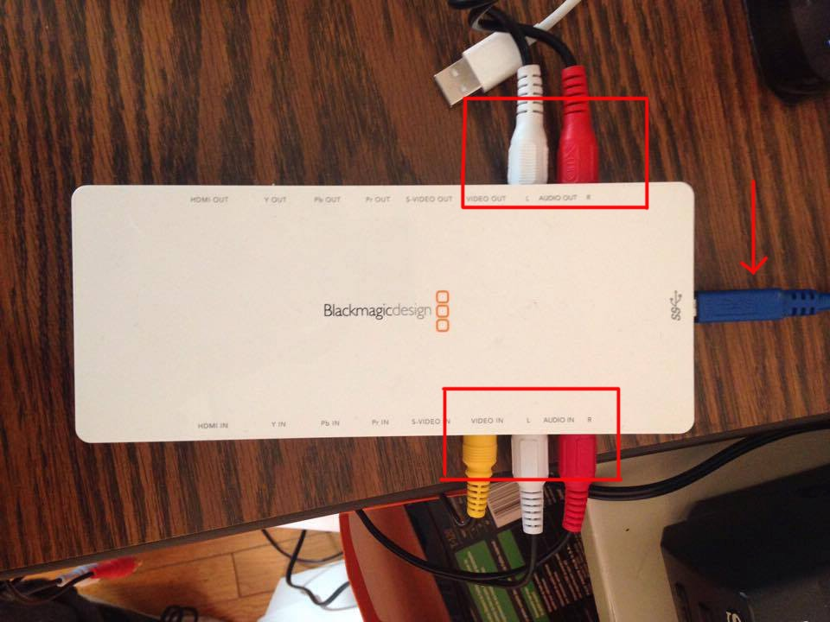
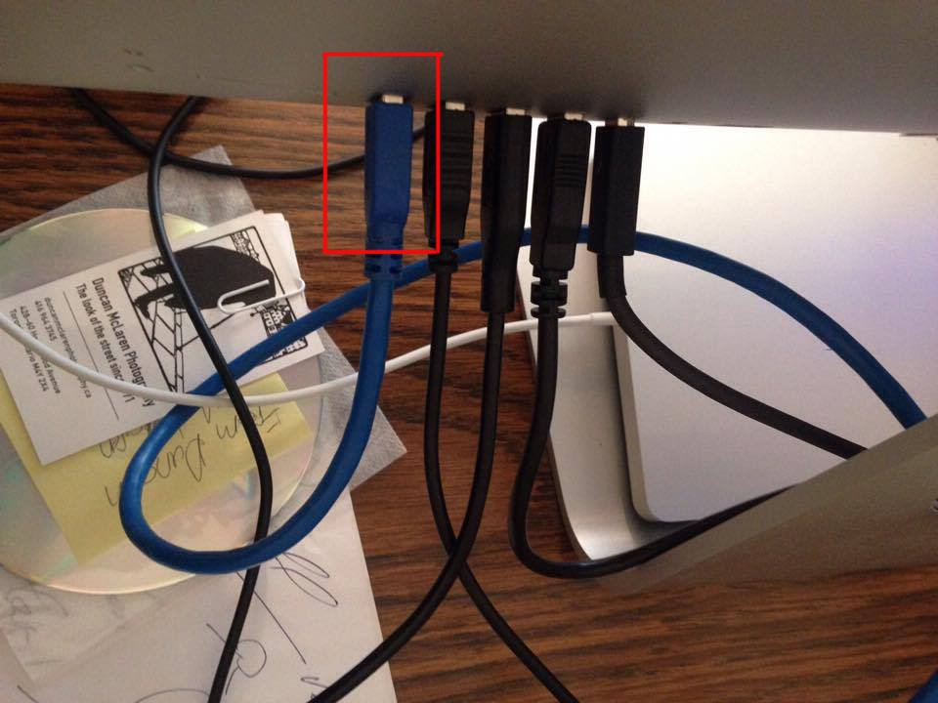
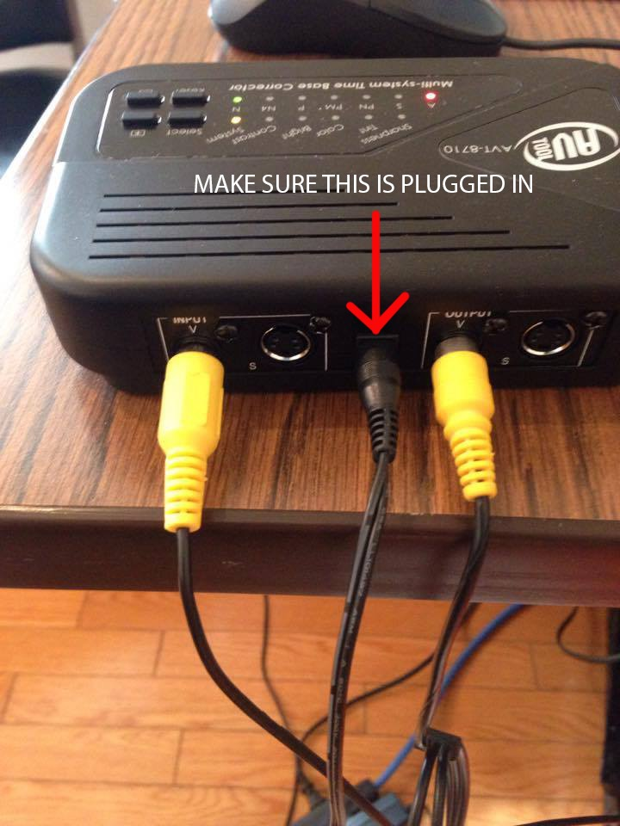
Note: disconnet the power to the Time Base Corrector when you are finished (it has no off button and overheats).
Figure 1 Video and Audio in to Infinity Shuttle (bottom), Audio out to Headphones (top), USB Cable out to iMac (right)
Figure 1 Infinity Shuttle Connection to iMac
Figure 1 Time Base Corrector
3) Steps to Digitize Tape

- Make sure all equipment is plugged in and properly connected
- Create a temporary folder on the iMac, in Documents, where you will store the files created through your project. Plug in one of the external hard drive and create a similar folder on the hard drive.
- Double click the “DIGITIZE VHS” icon on the computer desktop. The program “Media Express” will open.
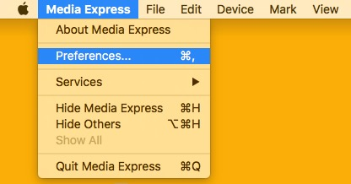
- Click on “MEDIA EXPRESS” in the top right hand corner of the screen (the finder bar). Go to PREFERENCES. Under CAPTURE AUDIO AND VIDEO TO, click BROWSE. Select folder you created on the computer as the destination folder.

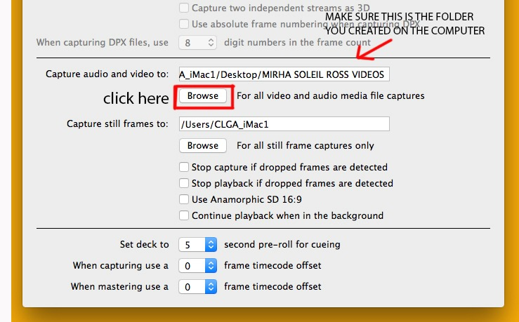
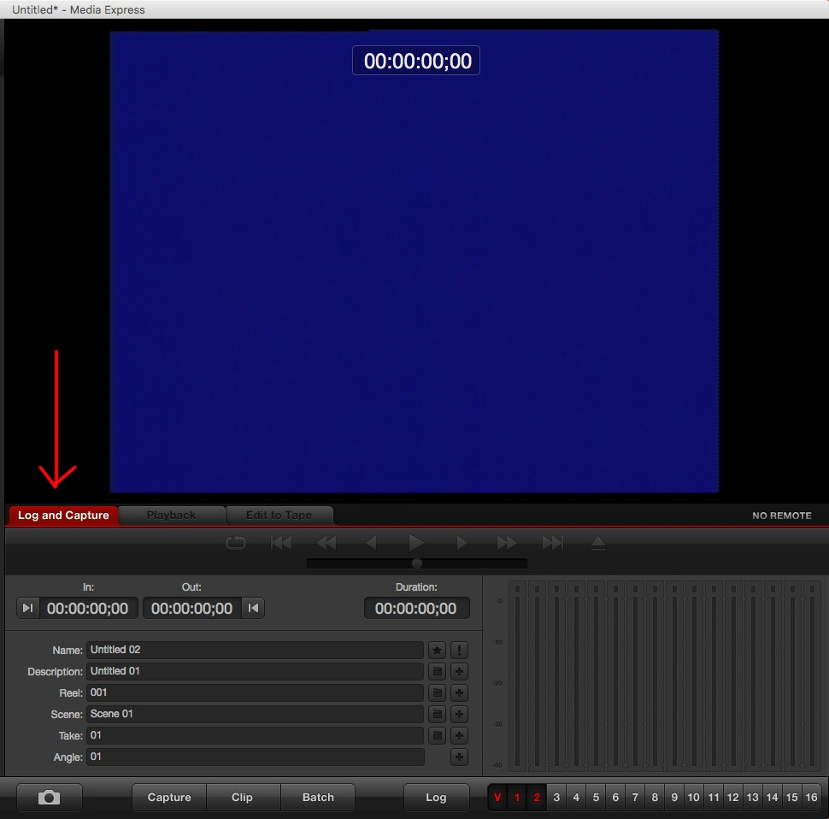
- Return to main screen of “MEDIA EXPRESS” and select the “LOG AND CAPTURE” tab.
Figure 4 Select "LOG AND CAPTURE"
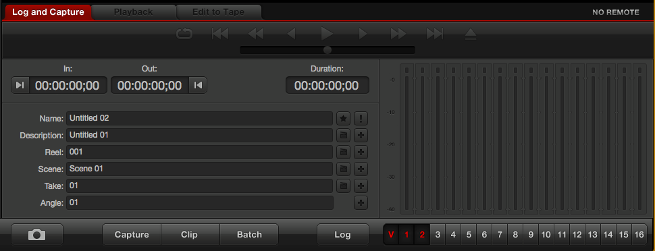
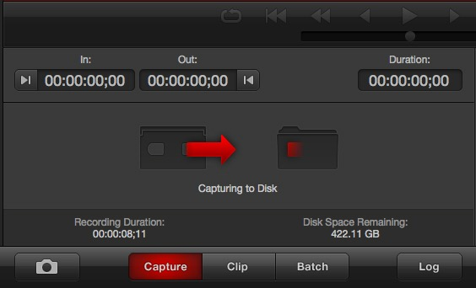
6) Make sure your VHS tape is rewound completely. Check the tape for any signs of debris, dirt or damage. If you find any of these signs, do not digitize the tape. Press PLAY on VCR, then immediately click the “CAPTURE” button in Media Express to begin the recording. Check that the sound is coming through the headphones and that the video appears to be running.
Figure 5 Detail of SELECT LOG AND CAPTURE
Figure 6 Media Express will display this graphic when it is capturing video to the computer.

- Once the video has finished running, click the “CAPTURE” button once more. This will stop the recording.

4) Saving, Naming and Managing Files

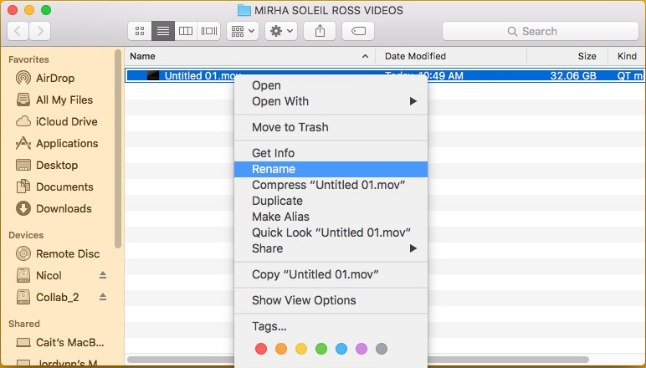
- Go to the folder you had created early on the computer. Your video file should now be there. Right click on the new video file and select “RENAME”. Delete the current information and rename the video file with it’s corresponding accession number, followed by the Video Title (i.e. 2008-073-05F Yapping Out Loud)
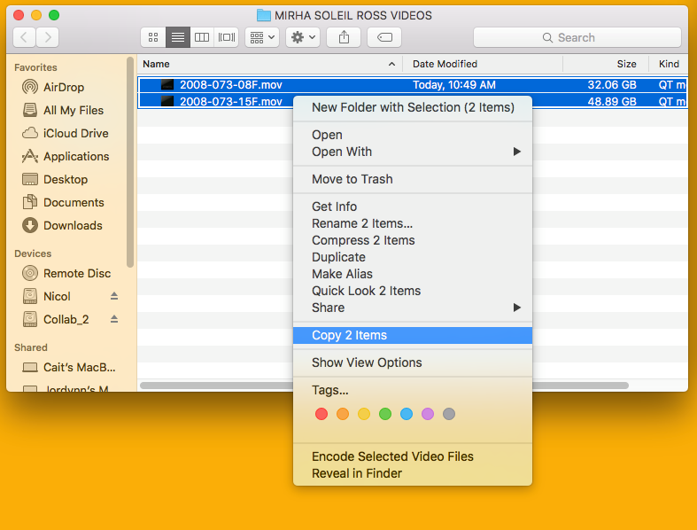
- Rewind the video in the VCR than press “EJECT” and return the cassette to its original case if applicable.
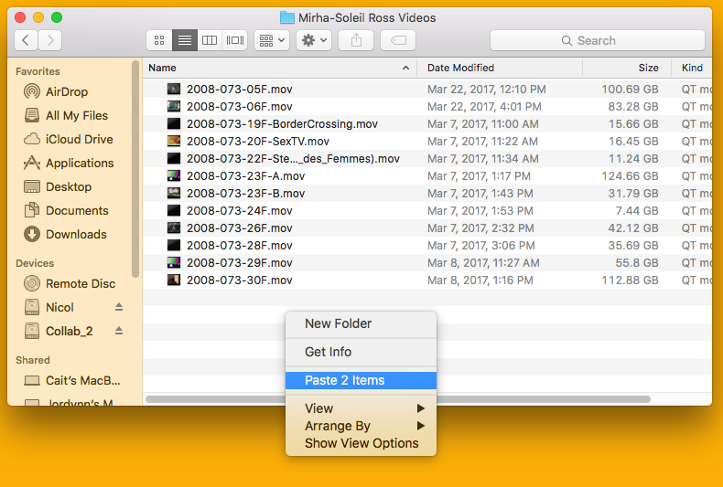
- Now it is time to copy the files you created over to the external hard drive. Even if you are digitizing many videos, this process should be completed after two files have been created, so that you do not lose work or fill up the iMac’s hard-drive. Copy the files to the matching folder on the external hard drive. Click and drag your mouse to select both files at the same time. Then RIGHT CLICK - COPY 2 ITEMS. Open the matching folder on the external hard drive and RIGHT - PASTE 2 ITEMS.

- While in the external hard drive right click on the file and select OPEN WITH - QUICKTIME. Make sure the video plays correctly and the audio is not out of sync. Sync problems can sometimes be cause by lag from the computer, in which case the files themselves are fine. If you notice a sync problem, try restarting the computer and closing other programs before playing the file.
- Once you have confirmed the copied files are functioning correctly return to the folder on the computer with the originally two files. Delete them by right clicking and selecting MOVE TO TRASH. Then RIGHT CLICK on the trash icon in the bottom dock and select EMPTY TRASH.

